
Pointers

Pointers do just what they sound like they do. They point to a space in memory, usually a location occupied by a variable. A pointer is an address in memory. The pointer itself is a variable, but it also refers to a variable. A pointer is declared using an asterisk (*) following the data type:

int *ptr; // The variable named ptr is of type int*

To indicate that a pointer variable is not pointing toward any usable data, we often set its value to NULL, which is defined as zero:

int *ptr = NULL;

C++11 provides a dedicated null pointer object called nullptr that can be used similarly:

int *ptr = nullptr;

There are two operators used in conjunction with pointers:

( * ) Also acts as a Reference Operator. The reference operator changes the pointer into the value it is pointing to.
( & ) is the Dereference Operator. A dereference operator exposes the address in memory rather than its value. Use this to set the value of a pointer to the address of a variable.

Lets declare pointer p and use it:
Code: | Output:
int *p;  int var1 = 2;  p = &var1;  cout << *p; | 2

Here is a more practical example:
Code: | Output:
int *p;  int var1 = 2;  int var2 = 4;  p = &var1;  p = var2;  cout << p << endl;  cout << var1 << endl; | 4  4

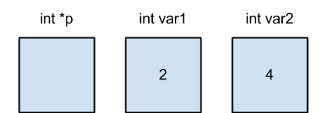
When the variables in the second example are declared (lines 1- 3):

After the fourth and fifth lines are executed, int *p will point to var1:
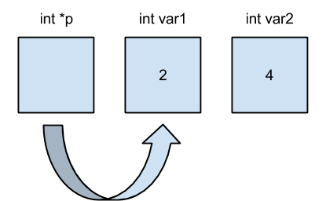

Finally, after the fifth line of code is executed, p is assigned the value stored in val2; since p points to val1, val1 receives that value:
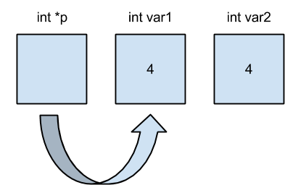

An important reminder is to use caution when declaring pointers. If you are declaring more than one pointer in a single line, you have to make sure to indicate each new, individual pointer with a “ * ” in front of the variable name.

Correct Declaration: | Correct Outcome of Declaration:
int *p, *q; | 1 new integer pointer named p  and  1 new integer pointer named q

Incorrect Declaration: | Incorrect Outcome of Declaration:
int *p, q; | 1 new integer pointer named p  and  1 new integer named q

Review Questions

1. What is the output of the following code

int *a, b, c;
a = &b;
b = 5;
c = 1;
b = b - b;
c = b * b;
*a = c - *a;
a = &c;
*a = c - 7;
c = c + c;
*a = *a + b;
c = c + b;
b = c - 3;
c = *a - 7;
cout << *a << endl;
cout << b << endl;
cout << c << endl;

2. What is the output of the following code?
int a, b, *c;
a = 7;
b = 4;
c = new int(2);
a = *c - a;
*c = *c + 4;
a = b + a;
c = &b;
a = a - b;
*c = b + a;
*c = *c - 1;
a = a * 1;
a = b - *c;
a = a - *c;
cout << a << endl;
cout << b << endl;
cout << *c << endl;

Review Answers

1. -21
-17
-21

2. 2
-2
-2

